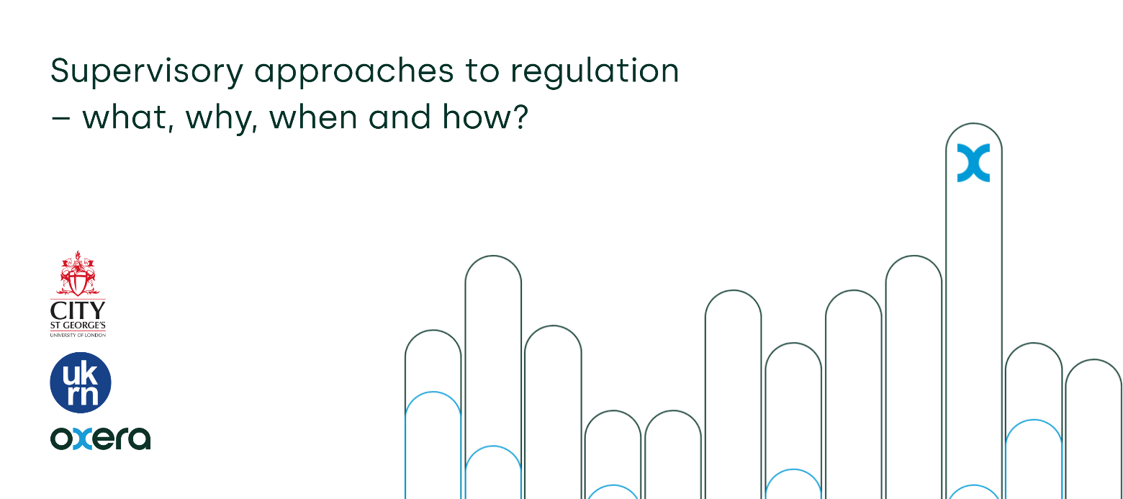
Supervisory regulation
This note is a reflection by the UKRN/Oxera on issues raised at the event jointly organized with the City St Georges, London University on 23 January 2026. At this event, Sir Jon Cunliffe presented some highlights from the report of the Independent Water Commission (IWC)on its review of the water sector. Sir Jon focused on the role of supervisory regulation and a raft of speakers shared their views about it.
What is supervisory regulation?
Given the extent of pressures on the water environment, the Commission decided that a continuous and comprehensive monitoring regime is needed and that a key feature of the regime should be the concept of ‘constrained discretion’. This underpins a framework whereby regulators have considerable flexibility to determine how best to deliver statutory outcomes in a local place or context, in line with a set of constraints or guardrails. A critical issue is how in practice this framework will be blended with existing practices such as periodic price reviews.
How might supervisory regulation work in the water industry and other sectors in which experience of it is limited?
The IWC report envisages supervisory regulation working alongside incentive regulation in a complementary way in the water sector, while ensuring that the overall regulatory burden does not increase disproportionately, and may in fact be reduced if designed well.
Experience in the financial sector suggests that good supervision depends first on the supervisors having good judgement, second on supervisors being able to obtain the information and intelligence they need to make good judgements ,and third on supervisors having systems that enable them to sort through (copious) information and intelligence and thereby focus on and make judgements about whatever the risks are that really matter in terms of their objectives and the outcomes that customers and others experience. None of this is straightforward. Various trade-offs are in play.
For sectors not previously subject to material supervisory regulation, an initial challenge may be to recruit supervisors with good judgment and a collaborative approach. For example, in water, extensive collaboration between different disciplines is necessary because the best decisions depend on combining economic, engineering, consumer and legal perspectives on an issue. Development of a culture to foster such collaboration is a vital issue for the top management of the regulator as is developing a training programme to carry it forward. Supervision can also allow for a level of ‘portfolio’ analysis and engagement in sectors where relationships are more typically defined through contracts.
We now explore each of the three elements of “good supervision’’ in turn.
Supervisory judgement
The quality of supervisory judgement really matters because supervisory discretion is central to most models of supervision. It is both the great strength of supervision – the ability to adapt the regulatory regime to the realities of the suppliers and broader market – and a great potential weakness: arbitrary exercise of discretion can chill investment, reduce innovation and needlessly increase the costs of regulation.
In any case, the first judgement to be made is where to set the boundary of supervision and detailed rules or common guidance that is developed for adoption by supervisors. Here the trade-off is between the certainty and often lower operating and capital costs that the common guidance provides and the flexibility – ability to drive the right outcome in practice – that supervision can offer. There is no easy way to set this boundary but factors to consider include:
- Regulation is essentially about improving economic outcomes (including the notion that people are willing to pay more for higher quality, while higher quality should reduce negative externalities). Rules can be subjected to CBA and reasonable predictions about their likely economic impacts generated ex ante.
- Supervision, on the other hand, is hard to subject to specific CBAs. The world is complex and becoming more so, implying that writing rules to capture optimal policy is becoming harder. Also, if the pace of development is increasing, the problem of rules becoming outdated is worsening. As mentioned above, the great strength of supervision (constrained discretion) is the ability to adapt the regulatory regime to the realities of the market, which importantly includes the actual behaviour of the relevant consumers.
- Equally, supervisory regulators must take into account that regulated firms need a degree of the certainty that rules can provide so that systems of operation and control may be designed and their own financial risks managed. This certainty is positive for investment and innovation.
Some of the issues described above are relevant to individual supervisory judgements, which typically are about whether intervention to address an identified issue will be net costly or, even if net costly, is justified in any event, for example as a signaling device.
Information and intelligence
Supervisors’ ability to obtain the information and intelligence they need to make good judgements is partly straightforward and partly gives rise to another difficult trade-off. The straightforward part is desk research, monitoring general and trade press, keeping up with relevant operational and technological developments and so on. The tricky part is developing a relationship with regulated firms that provides a reasonable prospect of private information that ought to be shared with supervisors actually being shared with supervisors. This likely requires a close relationship with regulated firms but supervisors must still maintain their independence and remember whom they serve (the public and Parliament).
There is a lot at stake here. Supervisors are often risk-averse, and there is a risk of capture through repeated interactions with regulated firms. The former state is especially problematic when regulators have sub-objectives relating to growth and innovation. The latter state is the one that can lead to disastrous outcomes for the public. Institutional design, independence, competency and transparency in decision-making are important means to calibrate and discipline supervisors’ necessary relationships with regulated firms. How can one best use governance and other mechanisms to get the incentives of supervisors aligned with the public interest and relevant statutory goals?
Again, this is not straightforward. For example, the oversight boards of regulators may need industry representation so that the realities of regulated markets are taken properly into account in decision-making. But, for example, industry representatives alone should not decide when these realties trump a regulatory plan rather than establish a cost to be taken into account in the regulatory judgement.
Equally, supervisors should not determine the plans of regulated businesses. Having supervisors as shadow directors could be very harmful to proactive management of networks and services and impact on the cost of capital as investors see that they cannot influence company performance in the way they would expect.
Focusing supervision on the things that matter
A common experience in supervisory regulation is that supervisors can be confronted by myriad uncomfortable facts and hypotheses about how the world is or how the world might be and lack the resources that would be required to address most, let alone all, of these uncomfortable issues. An important question, then, is how to sort through the facts and hypotheses and allocate scarce resources to the ones that are likely to matter most in practice. The answer that a supervisory regulator gives to this question is likely to have a material impact on its own success or failure.
In financial services, which appears to be the inspiration for the supervisory regulation referred to in the report of the Independent Water Commission, two broad approaches have been taken to resource allocation. One is to create a register of risks to objectives based on contributions from across the regulator itself. Each risk is given a score (and Red/Amber/Green status) based on multiplying its likelihood of crystallizing by its expected size. Then resources are allocated to the issues with the highest scores and to anything else which must be addressed for various reasons such as a statutory obligation.
The alternative, which underpins the FCA’s “Mission’’ document, starts with a map of markets used to assess which are working well and which are working poorly – because beneficial regulation generally depends on correcting market failure. For poorly working markets, an assessment is made of whether there is a remedy which could make the market work better and, if so, the scale of any net benefits (or net reductions in harm) arising. Resources can then be allocated to interventions with the highest expected net benefits. An important distinction from the risk-based approach is that it is not assumed either that intervention will solve the issue identified or that there will be net benefits.
Conclusion
At our joint event, several issues were identified for further consideration, including how supervisors can leverage cutting-edge private sector tools and technologies to better understand business models and market dynamics, and what principles should guide the exercise of supervisory discretion. At the same time, speakers highlighted the advantages of supervision; particularly, its ability to coordinate action in complex settings with multiple objectives or agencies, mitigate ratchet effects in benchmarking across geographies, and avoid over-reliance on economic models to determine efficient costs and investment needs.
A tentative conclusion of the day is that supervision has real merit in allowing for a more nuanced approach to managing regulatory relationships with companies, but it needs deep thought about:
- defining roles, responsibilities and limits,
- the resources and information available,
- developing system wide thinking on how supervision fits economically and effectively within existing regulatory arrangements, and
- obtaining a detailed understanding of the specific sector and characteristics of the regulated companies.

